MAXIMUM POWER POINT TRACKING IN WIND ENERGY CONVERSION SYSTEMS USING MACHINE LEARNING

SAHITYA TAHILIANI

2014A8PS775G

**This report is being submitted for fulfillment of the course**

DESIGN ORIENTED PROJECT **(INSTR F377)**

**Under the supervision of**

Dr. C. Balakrishna Moorthy

*Department of Electrical and Electronics Engineering.*



**BITS-Pilani K.K. Birla Goa Campus**

29 November 2016



# CONTENTS:

# 1. ABSTRACT:

# 2. KEYWORDS:

# 3. WIND ENERGY AND ITS IMPORTANCE:

# 4. WIND-ENERGY CONVERSION SYSTEMS:

# 5. MAXIMUM POWER POINT TRACKING:

# 6. COMMON METHODS USED FOR MPPT:

## *6.1 Perturb and observe*

## *6.2 Incremental conductance*

## *6.3 Current sweep*

## *6.5 Fuzzy Logic Control*

## *6.4 Constant voltage*

## *6.6 Neural Network*

# 7. COMPARISION BETWEEN DIFFERENT MPPT TECHNIQUES:

**8. BUCK CONVERTERS:**

# 9. IMPLEMENTED ALGORITHM:

# 10. MACHINE LEARNING

*10.1 LINEAR REGRESSION MODEL (MACHINE LEARNING USED):*

# 11. DESIGN PARAMETERS:

*11.1 INPUTS USED:*

*11.2 PARAMETERS INVOLVED:*

## *11.3 METHODOLOGY:*

## *11.4 METHOD:*

# 12. EQUATIONS AND APPROXIMATIONS USED IN THE PROPOSED DESIGN:

## *12.1 Terminology Used:*

## *12.2 Equations Formulated:*

## *12.3 Separately excited DC generator Model:*

# 13. MATLAB SIMULATION:

# 14*. EXPERIMENTAL RESULTS:*

**15. CONCLUSION:**

# 1. ABSTRACT:

In this report, an efficient and feasible algorithm to extract the maximum power point (MPP) in wind energy conversion systems (WECS) by implementing machine learning (ML) into perturb and observe (P&O) algorithm is presented. The proposed algorithm is simulated on a separately-excited DC generator. This model uses instantaneous measurements of wind speed, humidity, temperature, pressure and generator speed to estimate a MPP by using ML at the end of each iteration. From this estimated power point, the controller follows quick perturbation to calculate the accurate MPP and is used as training data for further predictions in the next iteration. The controller learns from this training set and estimates the MPP closer to the maximum achievable power (MAP) which is corrected again through perturbation and is recorded. With the progress of time, the approximation of the maximum power point becomes more accurate whilst the time in further perturbation required for modification decreases. This model adapts to the versatile climatic conditions and yields an efficiency of 99.95% in predicting the MAP at the end of 1000 iterations corresponding to 2.5 hours.

# 2. KEYWORDS:

Wind Energy Conversion Systems, Perturb and observe, Maximum Power Point Tracking, Artificial Intelligence, Machine Learning.

# 3. WIND ENERGY AND ITS IMPORTANCE:

Wind is a form of "SOLAR ENERGY**"**. Winds are caused by the uneven heating of the atmosphere by the sun, the irregularities of the earth's surface, and rotation of the earth. Wind flow patterns are modified by the earth's terrain, bodies of water, and vegetative cover. This wind flow, or motion energy, when "harvested" by modern wind turbines, can be used to generate electricity.

The costs of mining and transporting fossil fuels and nuclear power are highly variable, and the cost of electricity from these sources often fluctuates. Many experts consider wind power a viable alternative to buffer these costs because wind is fixed and free. The use of wind-generated electricity promotes cost-effective and renewable production of energy. Moreover, it reduces dependence on fossil fuel.

The benefits of wind energy are numerous. Wind energy is home grown, and local landowners and small businesses can operate single turbines or clusters of turbines. It doesn't emit contaminants into lakes and streams, and it doesn't produce hazardous airborne pollutants. Wind energy doesn't cause acid rain or contribute to global climate change. Most other sources of power, including natural gas and coal, produce greenhouse gases, whereas wind energy produces none. Wind energy has a minimal impact on crop production and livestock grazing as well, because wind farms cover only small areas of land.

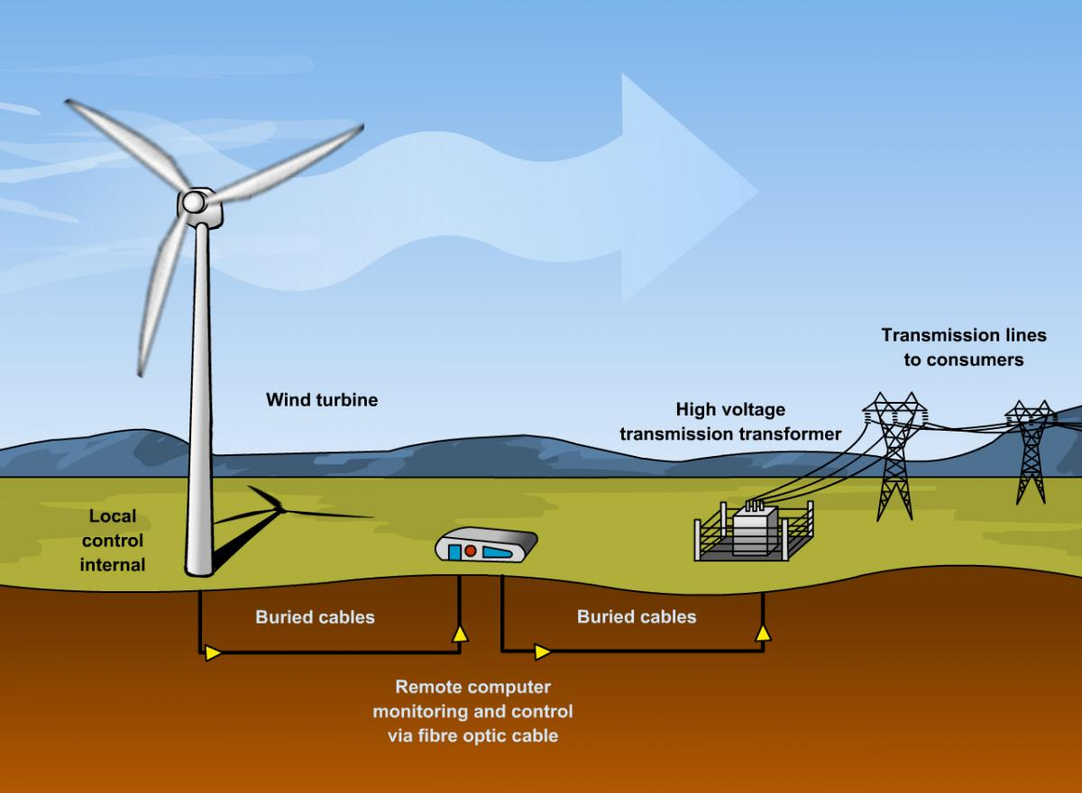

Fig.1: Overview of a Wind farm [1]

# 4. WIND-ENERGY CONVERSION SYSTEMS:

An apparatus for converting the kinetic energy available in the wind to mechanical energy that can be used to power up machinery (grain mills, water pumps, etc.) and/or to operate an electrical generator. The life span of modern wind turbines is now 20-25 years, which is comparable to many other conventional power generation technologies. The average availability of commercial wind power plants is now around 98%. The cost of wind power has continued to decline through technological development, increased production level, and the use of larger turbines.

The major components of a typical wind energy conversion system include a wind turbine, a generator, interconnection apparatus, and control systems. At the present time and for the near future, generators for wind turbines will be synchronous generators, permanent magnet synchronous generators, and induction generators, including the squirrel-cage type and wound rotor type. For small to medium power wind turbines, permanent magnet generators and squirrel-cage induction generators are often used because of their reliability and cost advantages. Induction generators, permanent magnet synchronous generators, and wound field synchronous generators are currently used in various high power wind turbines. Interconnection apparatuses are devices to achieve power control, soft start, and interconnection functions. Very often, power electronic converters are used as such devices. Most modern turbine inverters are forced commutated PWM inverters to provide a fixed voltage and fixed frequency output with a high power quality. Both voltage source voltage controlled inverters and voltage source current controlled inverters have been applied in wind turbines. For certain high power wind turbines, effective power control can be achieved with double PWM (pulse-width modulation) converters which provide a bidirectional power flow between the turbine generator and the utility grid.

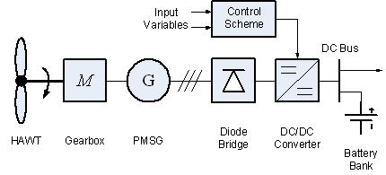

Fig.2: A typical Wind-Energy Conversion System [2]

# 5. MAXIMUM POWER POINT TRACKING:

Maximum power point tracking (MPPT) is a technique used commonly with wind turbines and photovoltaic solar systems to maximize power extraction under all conditions. Although solar power is mainly considered, the principle applies generally to all sources with variable power including wind energy convergence systems (WECS). The central problem addressed by MPPT is that the efficiency of power transfer from the wind turbine depends on both the Wind-speed and the electrical characteristics of the load. As the wind-speed varies, the load characteristic that gives the highest power transfer efficiency changes, so that the efficiency of the system is optimized when the load characteristic changes to keep the power transfer at highest efficiency. This load characteristic is called the maximum power point and MPPT is the process of finding this point and keeping the load characteristic there. Electrical circuits can be designed to present arbitrary loads to the wind-turbine and then convert the voltage, current, or frequency to suit other devices or systems, and MPPT solves the problem of choosing the best load to be presented to the cells in order to get the most usable power out.

Wind energy power output can be analyzed based on the I-V curve [3]. It is the purpose of the MPPT system to sample the output of the wind turbine and apply the proper resistance (load) to obtain maximum power for any given environmental conditions. MPPT devices are typically integrated into an electric power converter system that provides voltage or current conversion, filtering, and regulation for driving various loads, including power grids, batteries, or motors.

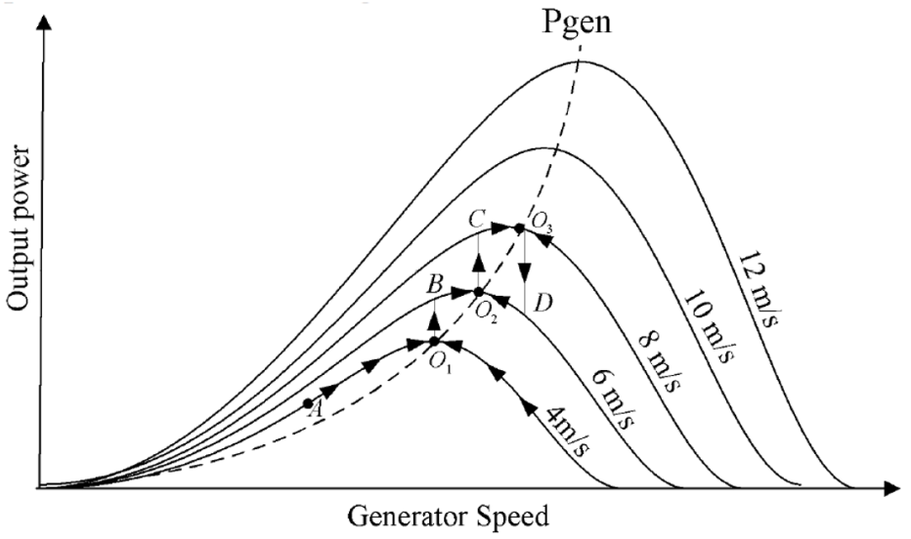

Fig-3: Output power vs. generator speed curve for a wind turbine (showing different maximum power-points O1,O2,O3 for different values of wind speed) [4]

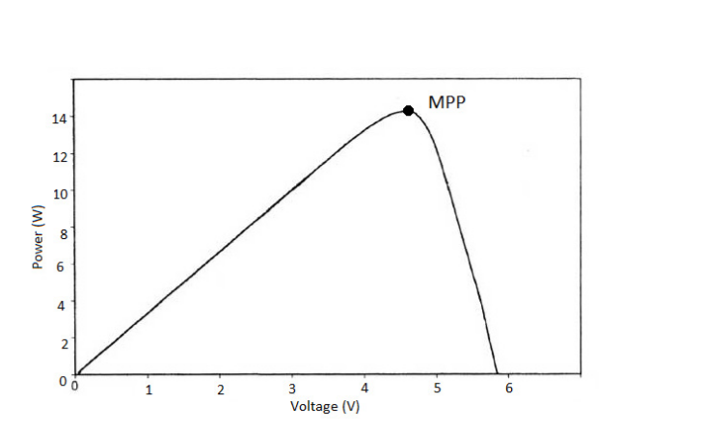

Fig-4: P-V characteristics curve of a Wind-Turbine (depicting Maximum Power-Point) [5]

# 6. COMMON METHODS USED FOR MPPT:

## *6.1 Perturb and observe*

In this method the controller adjusts the voltage by a small amount from the generator (Permanent Magnet Synchronous generator) load and measures power. If the power increases, further adjustments in that direction are tried until power no longer increases. This is called the perturb and observe method and is most common, although this method can result in oscillations of power output. [6] It is referred to as a **Hill climbing** **method**, because it depends on the rise of the curve of power against voltage below the maximum power point, and the fall above that point. Perturb and observe is the most commonly used MPPT method due to its ease of implementation. Perturb and observe method may result in top-level efficiency, provided that a proper predictive and adaptive hill climbing strategy is adopted.

## *6.2 Incremental conductance*

In the incremental conductance method, the controller measures incremental changes in generator (PMSG) current and voltage to predict the effect of a voltage change. This method requires more computation in the controller, but can track changing conditions more rapidly than the perturb and observe method (P&O). Like the P&O algorithm, it can produce oscillations in power output [7].This method utilizes the incremental conductance (*dI /dV*) of the generator to compute the sign of the change in power with respect to voltage (*dP/dV*). The incremental conductance method computes the maximum power point by comparison of the incremental conductance *(IΔ / VΔ*) to the generator conductance (I / V). When these two are the same (*I / V = IΔ / VΔ*), the output voltage is the MPP voltage. The controller maintains this voltage until the wind-speed changes and the process is repeated.

## *6.3 Current sweep*

The current sweep method uses a sweep waveform for the generator such that the I-V characteristic is obtained and updated at fixed time intervals. The maximum power point voltage can then be computed from the characteristic curve at the same intervals. [8]

## *6.4 Constant voltage*

The term "constant voltage" in MPP tracking is used to describe different techniques by different authors, one in which the output voltage is regulated to a constant value under all conditions and one in which the output voltage is regulated based on a constant ratio to the measured open circuit voltage (*VOC*). The latter technique is referred to in contrast as the "open voltage" method by some authors. If the output voltage is held constant, there is no attempt to track the maximum power point, so it is not a maximum power point tracking technique in a strict sense, though it does have some advantages in cases when the MPP tracking tends to fail, and thus it is sometimes used to supplement an MPPT method in those cases. In the "constant voltage" MPPT method (also known as the "open voltage method"), the power delivered to the load is momentarily interrupted and the open-circuit voltage with zero current is measured. The controller then resumes operation with the voltage controlled at a fixed ratio, such as 0.76, of the open-circuit voltage *VOC*. [9]  This is usually a value which has been determined to be the maximum power point, either empirically or based on modeling, for expected operating conditions. The operating point of the generator is thus kept near the MPP by regulating the voltage and matching it to the fixed reference voltage *Vref = k x VOC*. The value of *Vref*  may be also chosen to give optimal performance relative to other factors as well as the MPP, but the central idea in this technique is that *Vref* is determined as a ratio to *VOC*.

## *6.5 Fuzzy Logic Control*

Microcontrollers have made using fuzzy logic control popular for MPPT over last decade. Fuzzy logic controllers have the advantages of working with imprecise inputs, not needing an accurate mathematical model, and handling nonlinearity. [10]

## *6.6 Neural Network*

Another technique of implementing MPPT which are also well adapted for microcontrollers is neural networks. Neural networks commonly have three layers: input, hidden, and output layers. The number nodes in each layer vary and are user-dependent. The input variables can be generator parameters like VOC and ISC, atmospheric data like wind-speed and temperature, or any combination of these. The output is usually one or several reference signals like a duty cycle signal used to drive the power converter to operate at or close to the MPP [10].

# 7. COMPARISION BETWEEN DIFFERENT MPPT TECHNIQUES:

|  |  |  |  |  |
| --- | --- | --- | --- | --- |
| MPPT Technique | Speed of Convergence | Implementation Complexity | Periodic Tuning | Sensed Parameters |
| Perturb and Observe | Varies | Low | No | Voltage |
| Incremental Conductance | Varies | Medium | No | Voltage, Current |
| Fractional *Voc* | Medium | Low | Yes | Voltage |
| Fractional *Isc* | Medium | Medium | Yes | Current |
| Fuzzy Logic Control | Fast | Fast | Yes | Varies |
| Neural Network | Fast | High | Yes | Varies |

Table 1: Compares different MPPT techniques on different parameters. [10]

**8. BUCK CONVERTERS:**

A Buck Converter is a DC-to-DC converter that steps down the voltage whilst increasing current from the input supply to the output load. This device is essentially a switched-mode power supply typically containing minimum of two semiconductors (a transistor and a diode), a minimum of a capacitor, inductor, or a combination of both and is used for stepping down DC voltage. Buck Converters are highly efficient (up to 90%), making them useful for computational operations. A PWM signal is used for controlling the clock cycles of the stepping-down operation. A buck converter circuit is shown in Fig 5.

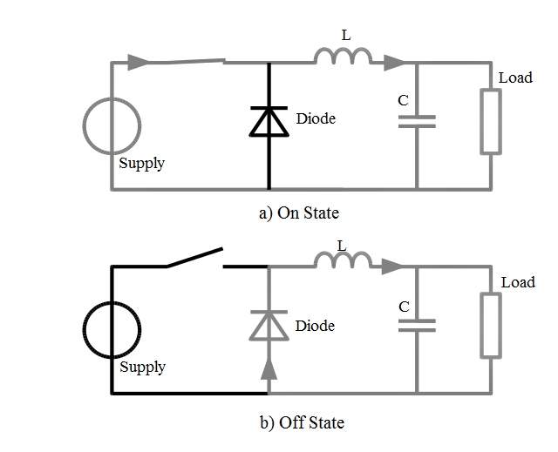

Fig. 5 Different States of a buck converter

# 9. IMPLEMENTED ALGORITHM:

In this method, a controller adjusts the output power of the separately excited DC generator by controlling the duty cycle (PWM) of the buck converter, and measures the rise and fall in power continuously. If there is an increment in the power on increasing the duty cycle, then the duty cycle is increased further in the same direction. If there is a decrement in power, then the direction is reversed and the process is repeated in the opposite direction until there is no further rise in power. Hence the characteristic parameters of this point being the maximum power point are recorded and the optimum power is generated using them. This algorithm is frequently used in wind power generation due to its ease of implementation. A flow chart depicting the P&O algorithm using buck converter is shown in Fig.6 (b), where Pi is the calculated power in the current iteration and Pi-1 is the power output for the preceding iteration. The system model is depicted in Fig. 6(a).

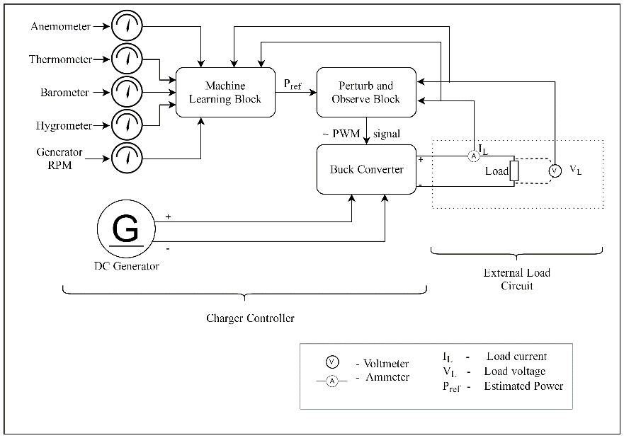

Fig. 6 (a). The configuration of wind energy conversion system

### 

Fig. 6(b) Flowchart depicting P&O algorithm

# 10. MACHINE LEARNING

Machine learning is a type of artificial intelligence (AI) that provides computers with the ability to learn without being explicitly programmed. Machine learning focuses on the development of computer programs that can teach themselves to grow and change when exposed to new data.  The process of machine learning is similar to that of data mining. Both systems search through data to look for patterns. However, instead of extracting data for human comprehension as is the case in data mining applications machine learning uses that data to detect patterns in data and adjust program actions accordingly.  Machine learning algorithms are often categorized as being supervised or unsupervised. Supervised algorithms (proposed) can apply what has been learned in the past to new data. Unsupervised algorithms can draw inferences from datasets. Behind the scenes, the software is simply using statistical analysis and predictive analytics to identify patterns in the data generated.

## *10.1 Localised linear regression model (MACHINE LEARNING USED):*

Linear regression assumes a linear relationship between the input variables (*x*) and the single output variable (*y*). More specifically, that y can be calculated from a linear combination of the input variables (*x*). When there is a single input variable (*x*), the method is referred to as simplelinear regression. When there are multiple input variables, literature from statistics often refers to the method as multiple linear regression. Different techniques can be used to prepare or train the linear regression equation from data.

### *10.1.1 Model Representation*

Linear regression is an attractive model because the representation is so simple. The representation is a linear equation that combines a specific set of input values (x) the solution to which is the predicted output for that set of input values (y). As such, both the input values (x) and the output value are numeric. The linear equation assigns one scale factor to each input value or column, called a coefficient and represented by the capital Greek letter Beta (B). One additional coefficient is also added, giving the line an additional degree of freedom (e.g. moving up and down on a two-dimensional plot) and is often called the intercept or the bias coefficient.

 (1)

For example, in a simple regression problem (a single x and a single y), the form of the model would be:

y = B0 + B1 (x) (2)

In higher dimensions when we have more than one input (x), the line is called a plane or a hyper-plane. The representation therefore is the form of the equation and the specific values used for the coefficients (e.g. B0 and B1 in the above example).

It is common to talk about the complexity of a regression model like linear regression. This refers to the number of coefficients used in the model.

When a coefficient becomes zero, it effectively removes the influence of the input variable on the model and therefore from the prediction made from the model (0 × *x* = 0). This becomes relevant if you look at regularization methods that change the learning algorithm to reduce the complexity of regression models by putting pressure on the absolute size of the coefficients, driving some to zero. [11]

### *10.1.2 Making Predictions with Linear Regression*

Given the representation is a linear equation, making predictions is as simple as solving the equation for a specific set of inputs.

Let’s make this concrete with an example. Imagine we are predicting weight (y) from height (x). Our linear regression model representation for this problem would be:

y = B0 + B1 × (x1) (3)

or

Weight =B0 +B1 × (height) (4)

Where B0 is the bias coefficient and B1 is the coefficient for the height column. We use a learning technique to find a good set of coefficient values. Once found, we can plug in different height values to predict the weight.

For example, let’s use B0 = 0.1 and B1 = 0.5. Let’s plug them in and calculate the weight (in kilograms) for a person with the height of 182 centimeters.

* Weight = 0.1 + 0.05×182
* Weight = 91.1

The above equation could be plotted as a line in two-dimensions. The B0 is our starting point regardless of what height we have. We can run through a bunch of heights from 100 to 250 centimeters and plug them to the equation and get weight values, creating our line. [11]

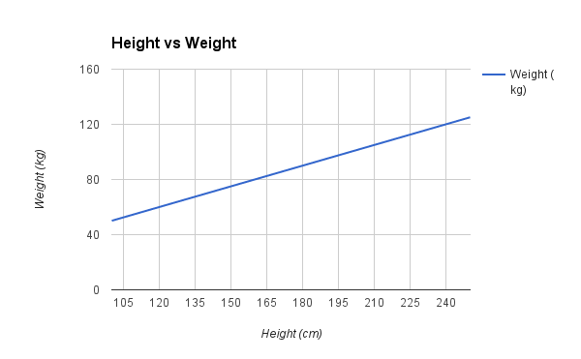

Fig-7. Graph between height and Weight from the example [11]

# 11. DESIGN PARAMETERS:

Maximum Power Point Tracking and DC Generator WECS using modified perturb and observe algorithm.

***11.1 INPUTS USED:***

* Wind Speed
* RPM of generator
* Temperature
* Humidity
* Pressure

**11.2 *PARAMETERS INVOLVED:***

🡪Voltage peak

🡪Current peak

🡪Resistance, Inductance, Torque

🡪Speed (ω)

🡪Flux Linkage

🡪Rotor Inertia

🡪Noise

## *11.3 METHODOLOGY:*

The MPP of the next instant on an ongoing WECS is calculated from previous data analysis by predicting the output load by means of machine learning and starting a hill climb search from this obtained output load. This reduces the time taken for doing an entire HCS from start.

### *11.3.1 INPUTS USED:*

* Wind Speed (as RPM)
  + Considering Constant Tip Speed Ratio (λ) [12]
* Air Density
* Area Perpendicular to the flow of Wind
* Power Coefficient
* Pressure
* Temperature
* Humidity

## 

## *11.4 METHOD:*

Follows a vigorous hill climb search for the maximum power point starting from the value obtained from the regression model with a precision of 10-3The corrected Value is re-updated into the training data for improving the accuracy of the system.

For the simulation of values and data, the following values were taken:

Ka = 50 units

Kf = 0.01 units

If = 2A

Rf = 1 Ώ

Ra = 3 Ώ

The data for various wind speed, temperature, humidity, pressure etc. was obtained from ‘***BITSPilani, K.K. Birla Goa Campus***’ in campus data provided.

# 12. EQUATIONS AND APPROXIMATIONS USED IN THE PROPOSED DESIGN:

The following equations and were used to design the simulation of the proposed design.

## *12.1 Nomenclature:*

*Eb* - Armature Voltage

*Ra* - Armature Resistance

*IL* - Load Current

*RL* - Load Resistance

*If* - Field Current

*V* - Voltage Across Load

*Kf* - Field Constant

*Ka* - Armature Constant

*W* - rotor speed (RPM)

## *12.2 Equations Formulated:*

(Considering separately excited DC generator and taking necessary assumptions):

V=Eb× RL/ (Ra + RL) (5)

IL= Eb/ (Ra + RL) (6)

Eb=(Kf) ×(Ka)×(If)×(w) (7)

Hence, the formulated equation for Power generated is: P=(V)x(IL)

P(Power)= [(Kf)×(Ka)×(If)×(w)/ (Ra + RL)]2×(RL) (8)

## *12.3 Separately excited DC generator Model:*

The purpose of a wind energy conversion system is to transform the mechanical energy into electrical form of energy. The mechanical power (Pm) fed to the wind turbine is described as kinetic energy(KE) of the wind turbine rotor blade per unit time:

 (9)

Here , is the air density, A is the area covered under the rotor blade and v is the wind speed (m/s). This is ideal power fed to the wind turbine. But there is a theoretical limit to which this power can be utilized in practice. This limit is governed by Betz’s law, which illustrates the maximum power extractable from the wind turbine, independent of its design

According to the Betz's law, no turbine can capture greater than 59.3% of the kinetic energy of the wind. The generated power by the wind turbine depends on the efficiency factor, also known as coefficient of  performance Cp(,β) of the wind turbine which depends on the pitch angle (β) and the tip speed ratio (). Tip speed ratio is the ratio of turbine speed to the wind speed and is given by:

 (10)

where, ⍵ is angular speed of the turbine and R is the radius of the turbine blade. Hence, the actual power (*P*) generated by the wind turbine is as follows:

 (11)

The coefficient of performance has a maximum value of 0.593(Betz’s Law) The turbine’s coefficient of performance is an exponential non-linear function and is expressed by :

 (12)

Where, β is the pitch angle and is,

 (13)

The characteristic curve for coefficient of performance Cp(,β) versus tip speed ratio() for different values of the pitch angle (β) is shown in Fig.9:

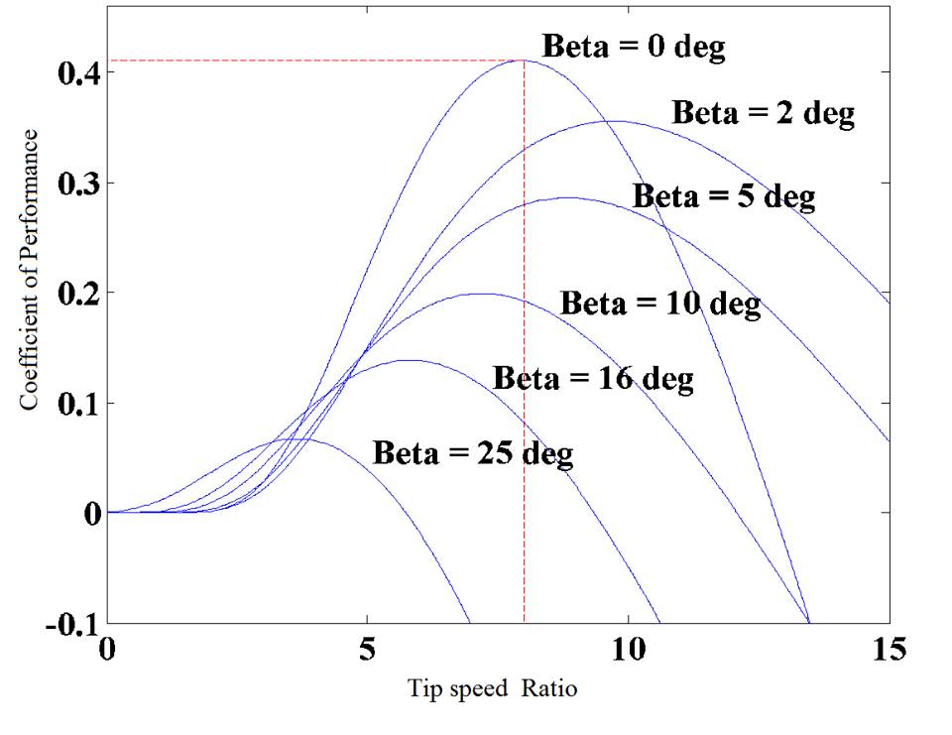

Fig. 9. Cp(, β) vs  characteristic curve for different

# 13. MATLAB SIMULATION:

The MATLAB simulation takes inputs of the generator speed, pitch angle [constant], wind-speed to the turbine and generates Torque(Tm) for the PMSG (Permanent Magnet Synchronous Generator). A permanent magnet synchronous generator is a generator where the excitation field is provided by a permanent magnet instead of a coil. The term synchronous refers here to the fact that the rotor and magnetic field rotate with the same speed, because the magnetic field is generated through a shaft mounted permanent magnet mechanism and current is induced into the stationary armature. PMSG being an AC Machine in nature generates three-phase output which is converted to DC using a universal bridge. Finally, DC Values of Current and Voltage are generated which account for a power statistic. This Generated Power is altered by variable impedance (Resistance for the proof of concept) which results in an increment/decrement in the Voltage/Current. Hence, the results from the P&O algorithm will be given as input into the regression model equation in ML to solve and determine an optimum power generating load for different input parameters mentioned.

# 14.EXPERIMENTAL RESULTS:

A graph between maximum available power (MAP) and predicted MPP is shown in Fig 10.

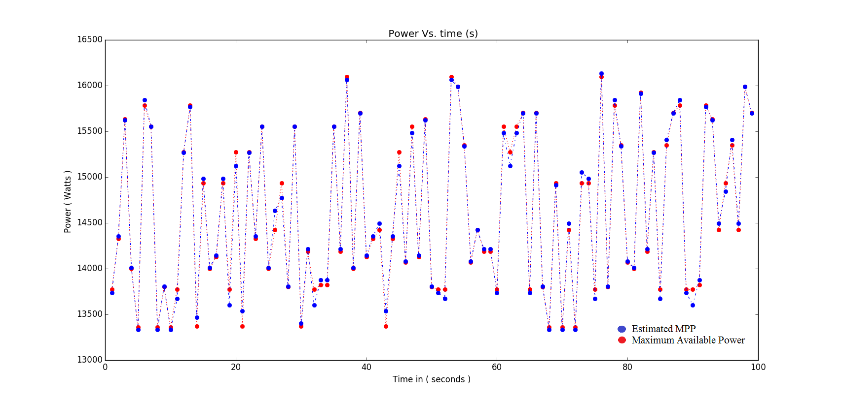

Fig. 10. Comparison of estimated Power φt (blue) and maximum available power (MAP) Pt (red)

The prediction of function to the actual MPP () is much more accurate to . Fig. 10 shows the mean error in estimating the same value after each iteration. It is evident that the error is decreasing. After each iteration, the system fits more patterns and the error obtained decreases with time. Hence, the system learns.

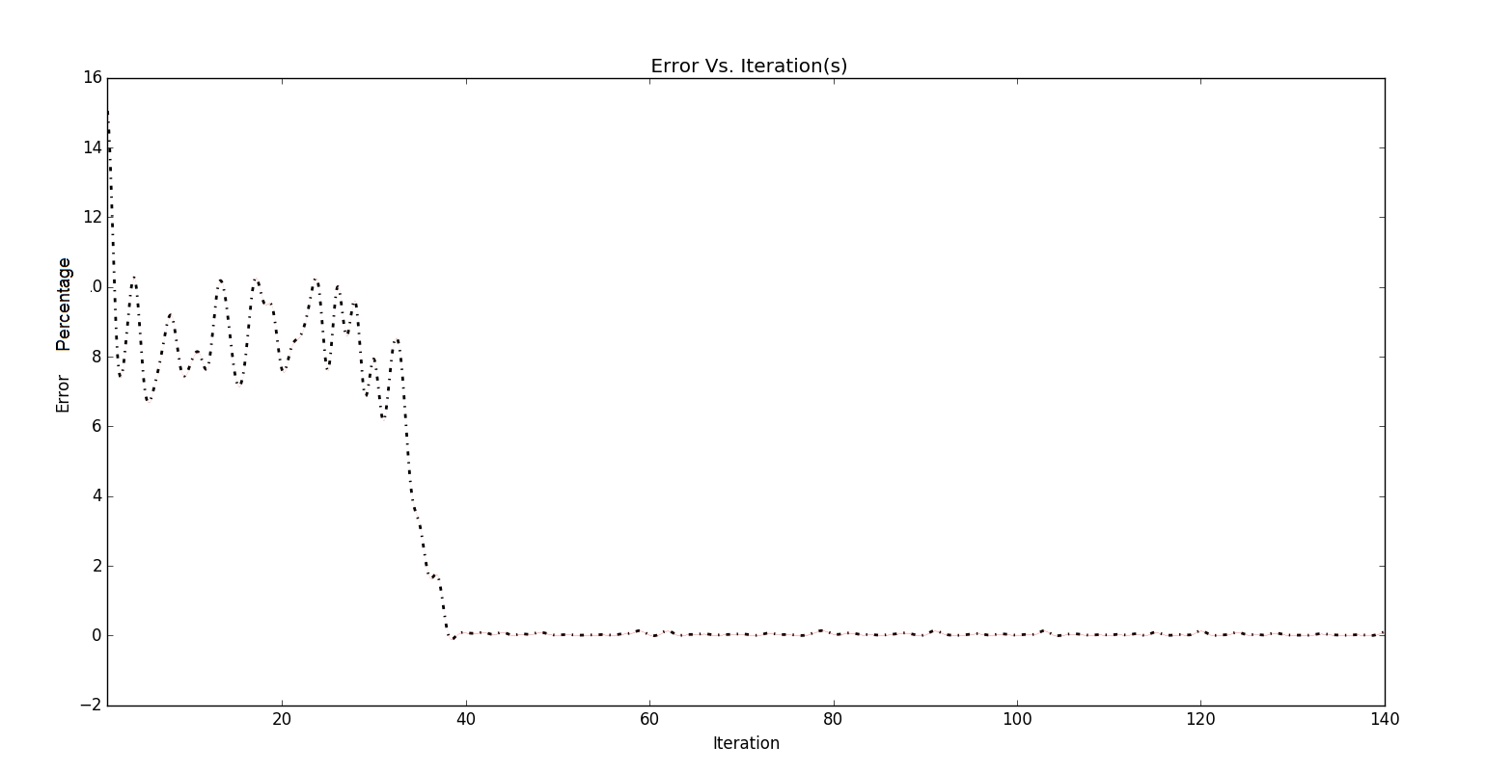

Fig.11. Mean error at each iteration

From Fig. 12, the eﬃciency of the proposed MPPT model at 1000 iterations which corresponds to 2.5 hours, is greater than 99.95% for estimating the MPP. Hence, the proposed MPPT algorithm is highly adaptive, eﬃcient and eﬀective. The percentage error (∆) is as follows:

 (14)

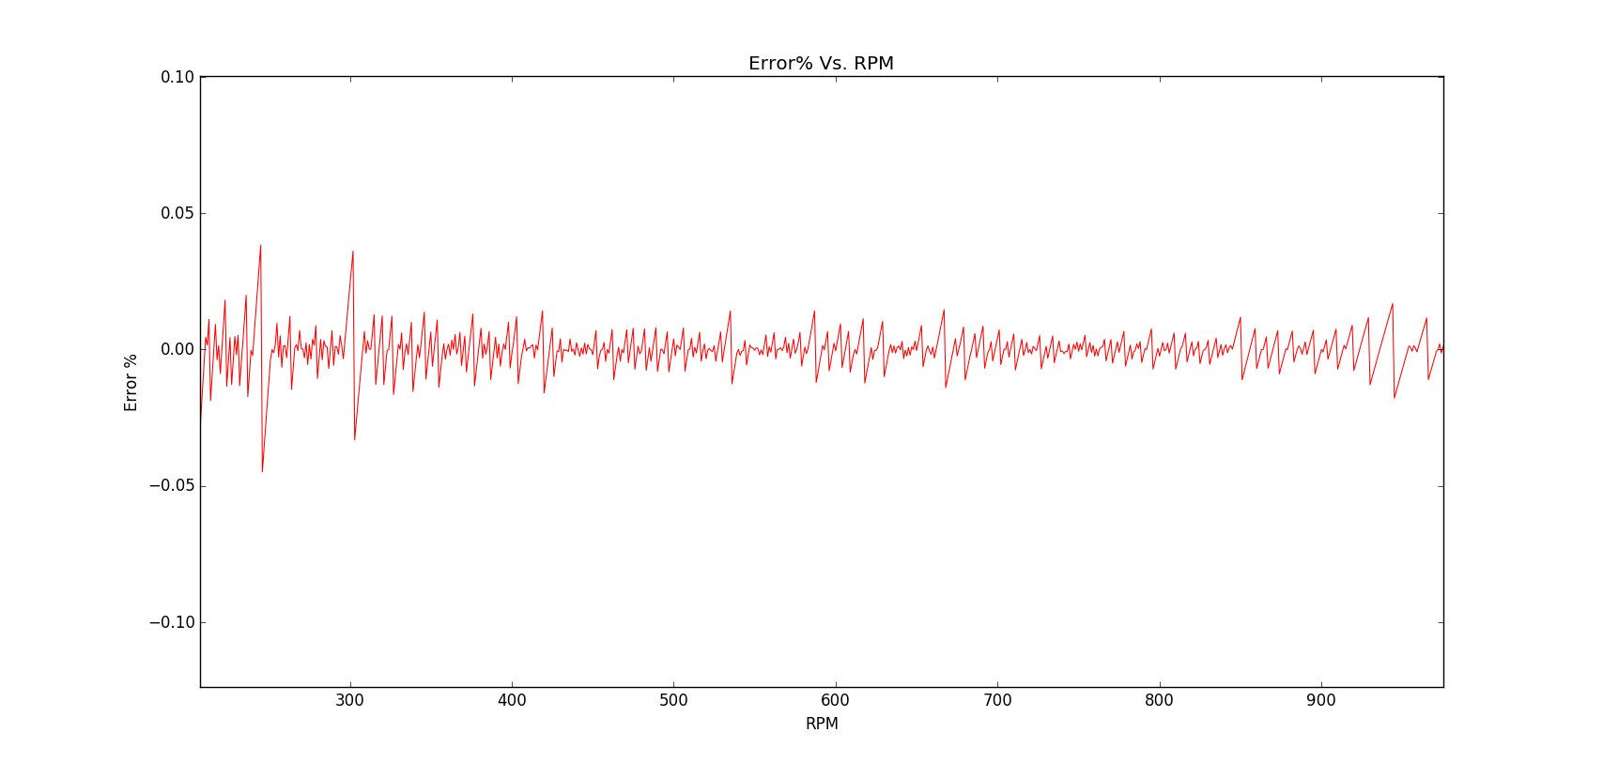

Fig. 12. Percentage error at each RPM of the DC generator at time t = 2.5 hours or 1000 iterations

The Figures 13 and 14 show the dynamic responses of the generated voltage and current obtained from the proposed MPPT algorithm with respect to time. In this domain, a validation dataset obtained from P&O is fed back, after each iteration into the training data, this limits the errors from increasing. Thus, machine learning overcomes overﬁtting that usually occurs in other AI algorithms such as artiﬁcial neural networks (ANN) and other logic based control systems.

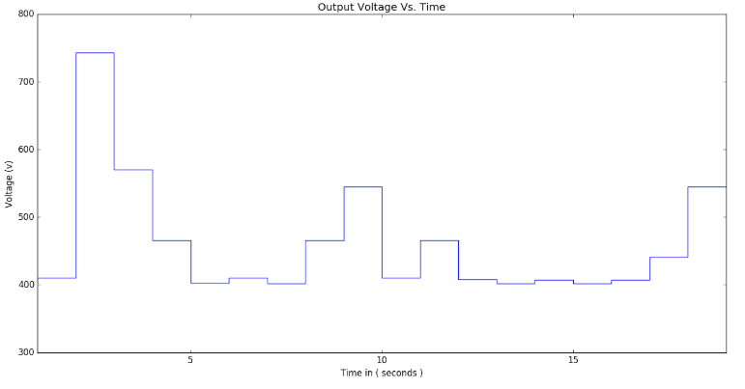

Fig. 13 Output Voltage based MPPT control

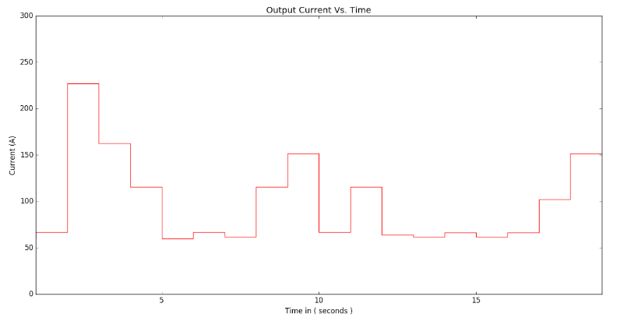

Fig. 14. Output Current based on MPPT control

Finally, the performance of the modified MPPT control mechanism using Machine Learning technique is detected based on the efficiency (t) as shown in Eq.14.

 (15)

**15. CONCLUSION:**

# In this paper, an intuitive method to track maximum power point during hasty and rapid weather changes is described. A python simulation of a wind energy conversion system with a DC load has been carried out to validate the proposed MPPT method. The results showed that the proposed MPPT method tracked the MPP with insignificant fluctuations. Observations show that the performance and accuracy of the proposed algorithm is not affected by alterations in load. The perturbation time increases during unexpected wind speeds, but the proposed algorithm gradually learns and adapts to the new weather conditions. The main advantages of the proposed MPPT control method are faster convergence to the MPP, robustness, higher efficiency and its ease of implementation. The system is a modified algorithm of P&O and can be cascaded to the existing P&O equipment with convenient setup and resulting in better efficiency

**REFERENCES:**

|  |  |
| --- | --- |
| [1] | L. Alt E Wind & Solar, "http://www.altewindandsolar.com/ResidentialWind.html," [Online]. |
| [2] | C. 6-D and A. -. Chile, "http://www.scielo.cl/scielo.php?script=sci_arttext&pid=S0718-33052009000300006," [Online]. |
| [3] | M. Seyedmahmoudian, A. Mohamadi, S. Kumary, A. M. T. Oo and A. Stojcevski, A Comparative Study on Procedure and State of the Art of Conventional Maximum Power Point Tracking Techniques for Photovoltaic System. |
| [4] | S. M., C. A. and S. B, "Sensorless power maximization of PMSG based iso‐lated wind-battery hybrid system using adaptive neuro-fuzzy controller," *IEEE Indus‐try Applications Society Annual Meeting ,IAS 2010,* 3-7 October 2010. |
| [5] | D. Marcelo, Comprehensive approach to modeling and simulation of Photovoltaic arrays. |
| [6] | "http://ussolarinstitute.com/glossary/maximum-power-point-tracking/," Solarbuildings.ca. [Online]. |
| [7] | U. o. A. Wang.X, *Control Design for Distributed Photovoltaic Systems,* 2004. |
| [8] | Hart, Branz and Cox, "Experimental tests of open-loop maximum-power-point tracking techniques," *Solar Cells,* vol. 13, p. 185–195, 1984. |
| [9] | S. Ferdous, M. A. Mohammad, F. Nasrullah, A. M. Saleque and A. Muttalib, "Design and simulation of an open voltage algorithm based maximum power point tracker for battery charging PV system," in *IEEE*, 20-22 Dec. 2012. |
| [10] | L.Patrick, Comparison of Photovoltaic array maximum power point tracking technique. |
| [11] | J. Brownlee, "http://machinelearningmastery.com/linear-regression-for-machine-learning/," [Online]. |
| [12] | M. Ragheb, "Optimal Rotor Tip Speed Ratio," 2014. |
| [13] | D. P. Kothari and I. G. Nagrath, "Electric Machines," in *Electric Machines 4th Edition*, 2010, p. 907. |
| [14] | "http://circuitglobe.com/types-of-dc-generator-separately-excited-and-self-excited.html," [Online]. |
| [15] | V. G. K. Shah, S.Josh and N.Patel, "Maximum Power Point Tracking Methods for Wind and Solar Conversion Systems for Standalone Generation PSIM based Perturb and Observe Method," 2015. |
| [16] | K. E. Johnson, L. Y. Pao, M. J. Balas and L. J. Fingersh, “Control of variable-speed wind turbines: Standard and adaptive techniques for maximizing energy capture, IEEE, 2006. |
| [17] | P. D. Linus Ranjin M, "Maximum Power Point Tracking and Grid feeding of Permanent Magnet Synchronous Generator based Wind Energy Conversion System Using Modified Hill Climb Searching Algorithm," *IET Renewable Power Generation,* vol. 9, no. 6, p. 682 – 689, 2015. |